# To be held at the

***4* Novotel Hotel***

***East Midlands, Long Eaton Nottingham***

### Friday 14th October to Monday 17th October 2016

***Price includes:-***

***3 nights half board, ensuite accommodation***

***Reduction on selected drinks at the bar each evening– with voucher***

***Saturday Night 4 course Gala Dinner with suitable entertainment***

***Wine or juice reception on Gala Night***

***Tot of Port for the Gala night toast***

***Full use of hotel leisure facilities***

***Free Parking***

***3 night/ 4 day package £174***

***2 night/ 3 day package £137***

***1 night package £82***

***Gala night dinner £37***

***Add EXTRA*** **nights at a cost of £49.00 per person per night half board**

**Date of Arrival ............. Date of Departure ...................... Number of Nights ..................**

**There are no supplements for single rooms but these are limited and need to be booked early**

***Optional Excursion to Newark Air Museum or Newark Town on Saturday***

***£7.00 per head for the trip plus entry to Newark Air Museum £7.50***

***Please tick ..... if you wish to go. How many for Air Museum......***

***We will add this cost to your invoice.***

***Optional Excursion on Sunday to Scampton Inc Lunch £17.00 per head.***

***Please tick .......if you wish to go. We will add the cost to your invoice.***

## Personal Details

***Name………………………………………………………………………………………***

***Address………………………………………………………………………………………………………………………………………………………………………………….***

***Post Code………………***

***Telephone Number including Dialling code…………………………………………….***

***E Mail Address ..............................................................................................***

***Your Party***

***Names of other persons included on this booking form………………………………… ………………………………………………………………………………………………………………………………………………………………………………………………………………………………………………………………………………………..***

***Number of Persons………..***

***Rooms required: Double….……...Twin………….Single…..…….***

***Whilst every effort will be made to accommodate all special requests this will be done on a first come first served basis and not guaranteed.***

***Special Requirements such as diet / walking difficulties – Hotel does have a lift .....................................................................................…………….......….***

***The more you can tell us about the special needs you may have the easier it will be for us to accommodate you in the best place.***

***All prices are inclusive of VAT @ 20%.***

***Book Now to avoid disappointment, places are limited.***

***Cheques to be made payable to IOW Tours Ltd.***

***Please return this form with your remittance to:***

***Isle of Wight Tours Ltd,***

***3 New Road, Lake, Sandown, Isle of Wight, PO36 9JN.***

ALL HOLIDAYS ARE SUBJECT TO AVAILABILITY AT THE TIME OF BOOKING. SPACE IS NOT GUARANTEED UNTIL THE DEPOSIT IS PAID.

A non refundable deposit of

£10.00

Per person is required with this booking form.

Travel Insurance

We recommend that Travel Insurance is taken. IOW Tours can arrange this for you.

We do / do not require insurance

Please delete as required.

I enclose a Deposit or

Full Payment* of £…….

for …. Persons (delete as applicable)

or

**Debit my Access/Visa**

**Switch / Delta Account**

**Card Number**

**…………………**

**…………………**

**Switch/Delta Only, Issue Number……….**

**Valid From Date**

**……………….**

**Expiry Date**

**………..……… Signature**

**………………..**

**Cardholders Name……………**

**Security Number**

**…………………**

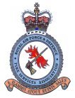

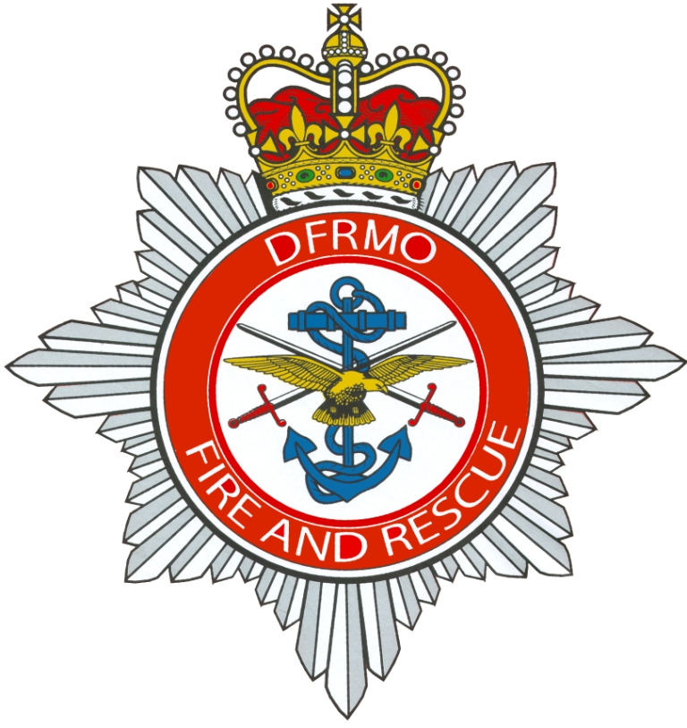

***RAF&DFSA Annual Reunion and AGM Booking Form 2016***